Screenshots

Dashboard 1

Cards:
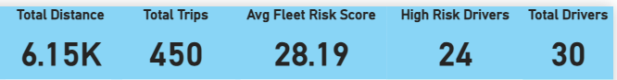

Visual 1 — Driver Risk Ranking (Horizontal Bar Chart):
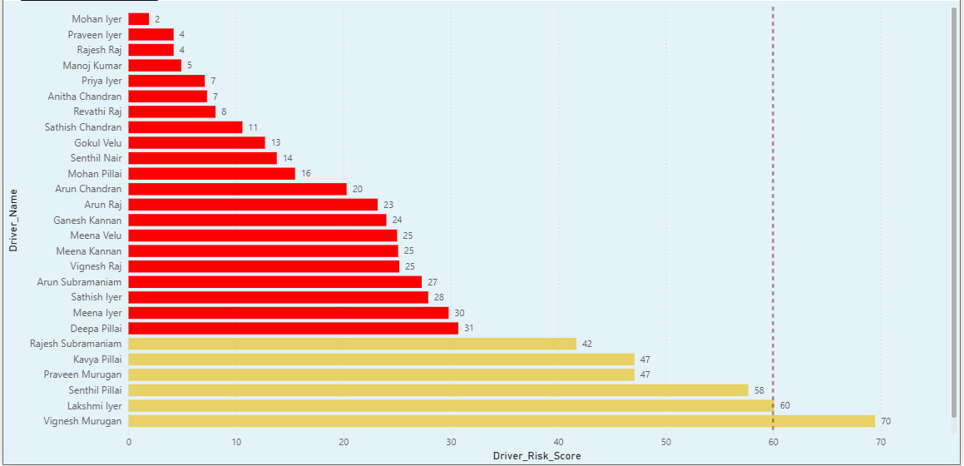

Visual 2 — Harsh Events Breakdown (Stacked Bar Chart)
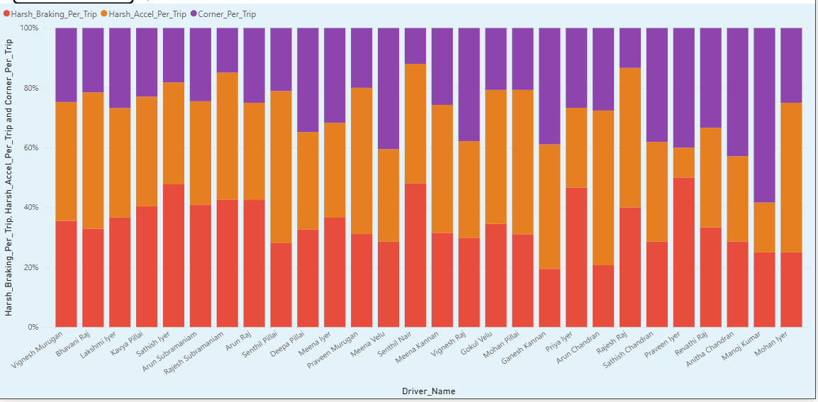

Visual 3 — Driver Aggressiveness Matrix (Scatter Plot)
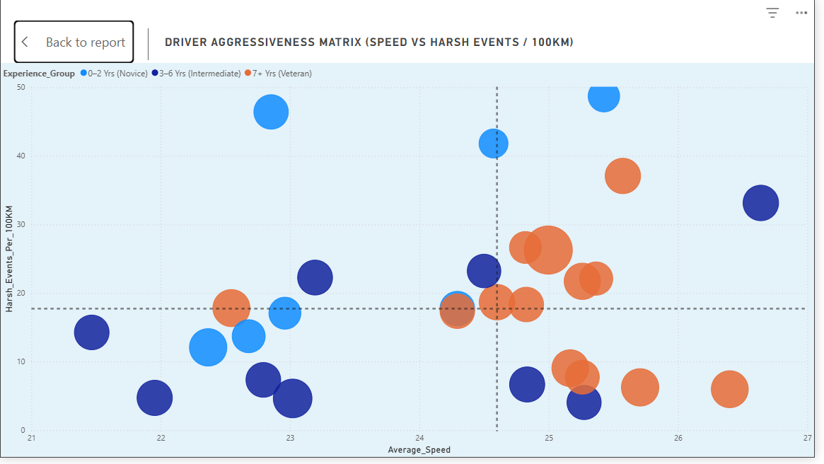

Visual 4 — Daily Fleet Risk Trend (Line Chart)
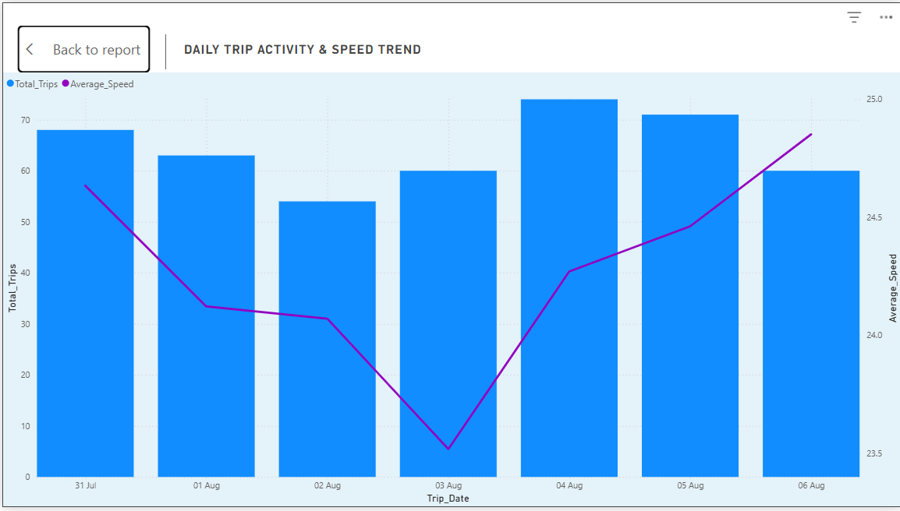

Visual 5 — GPS Route
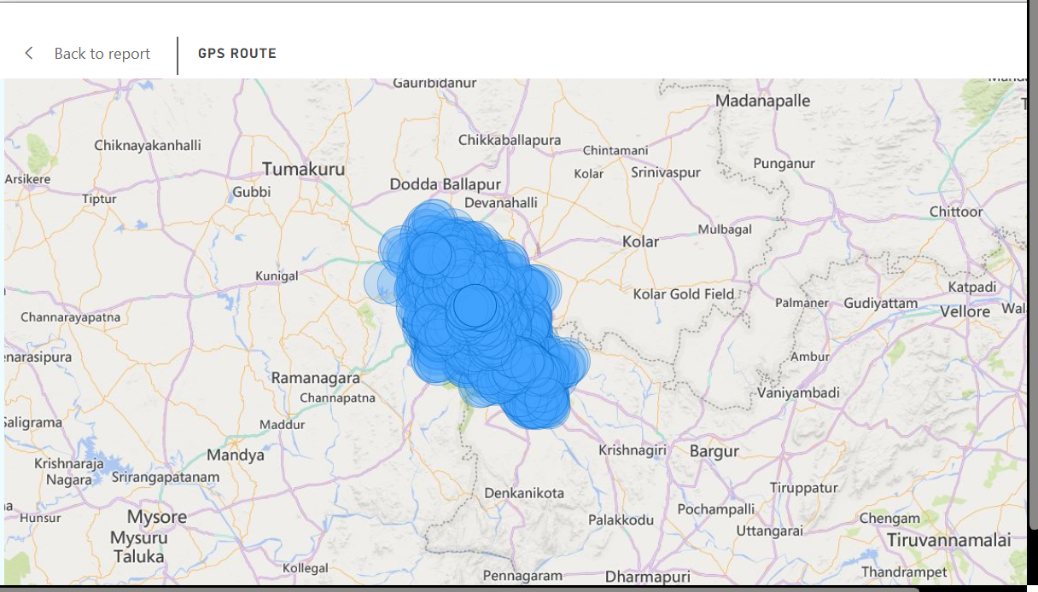

Slicers
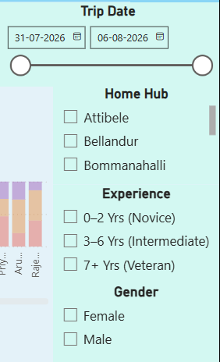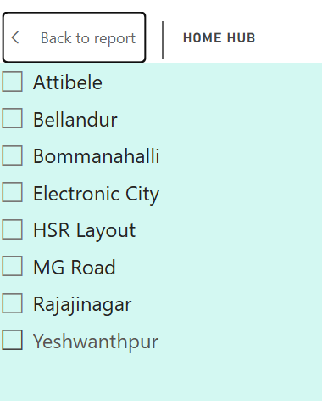
Driver Telematics:
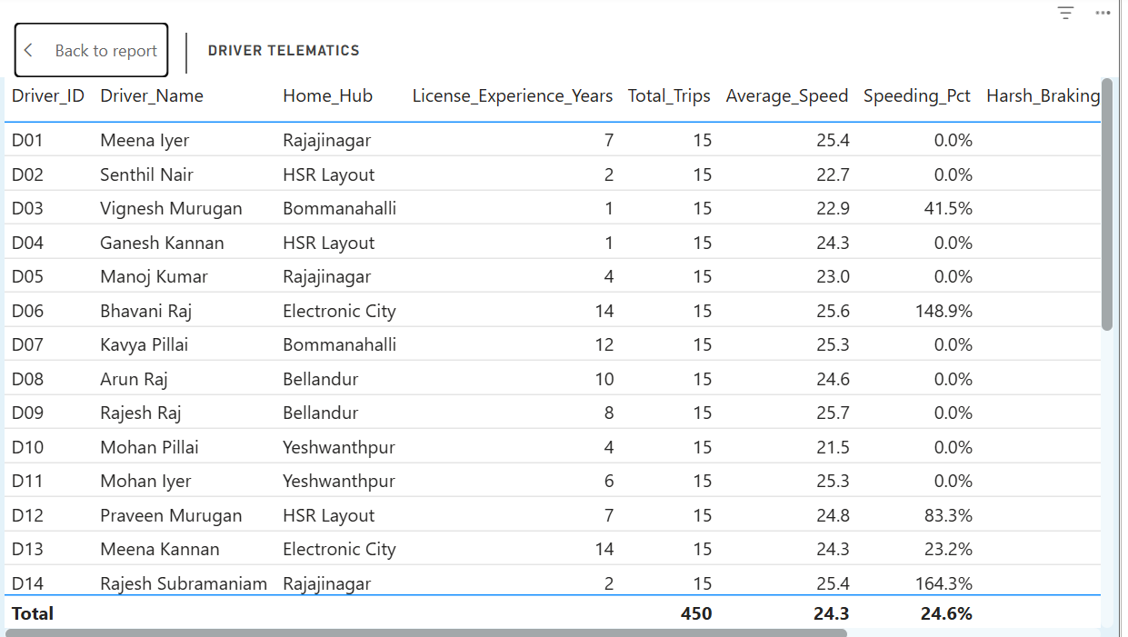

Daily Fleet Risk
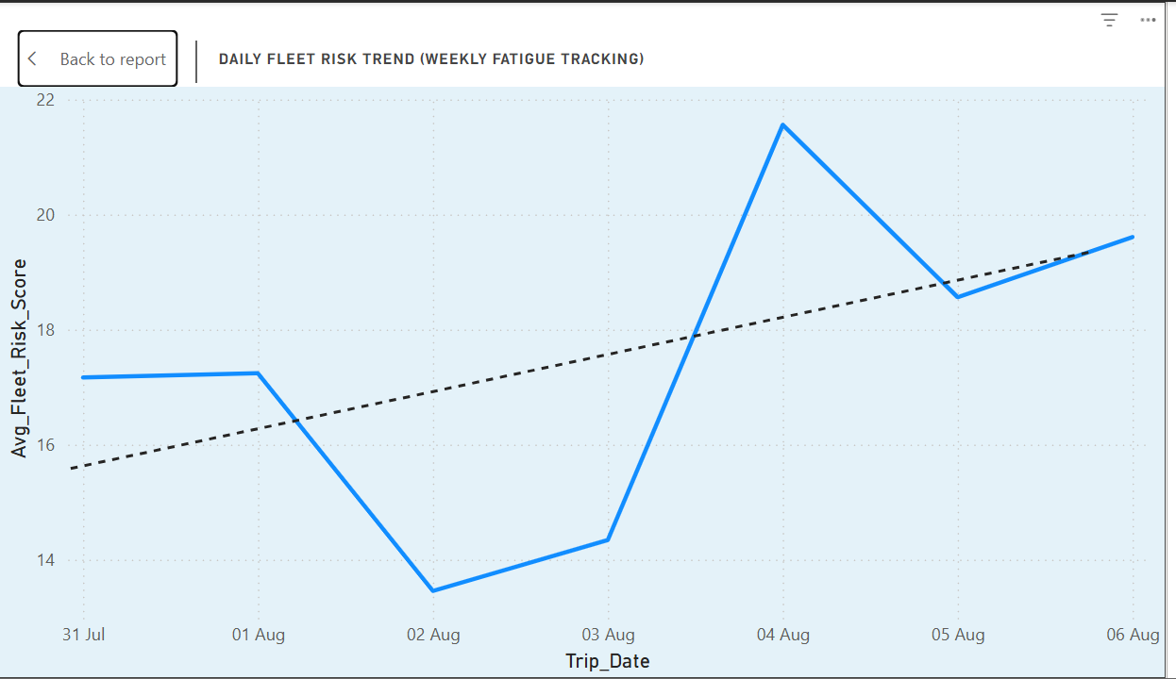

Dashboard:
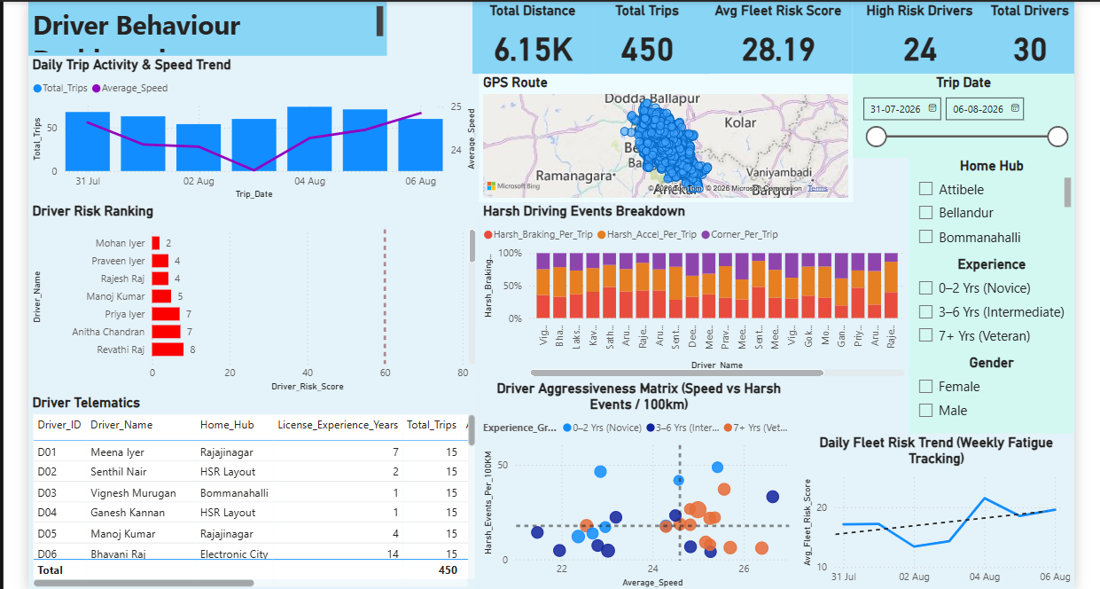

Dashboard 2

Visual 1 — Vehicle Vibration Ranking (Horizontal Bar Chart)
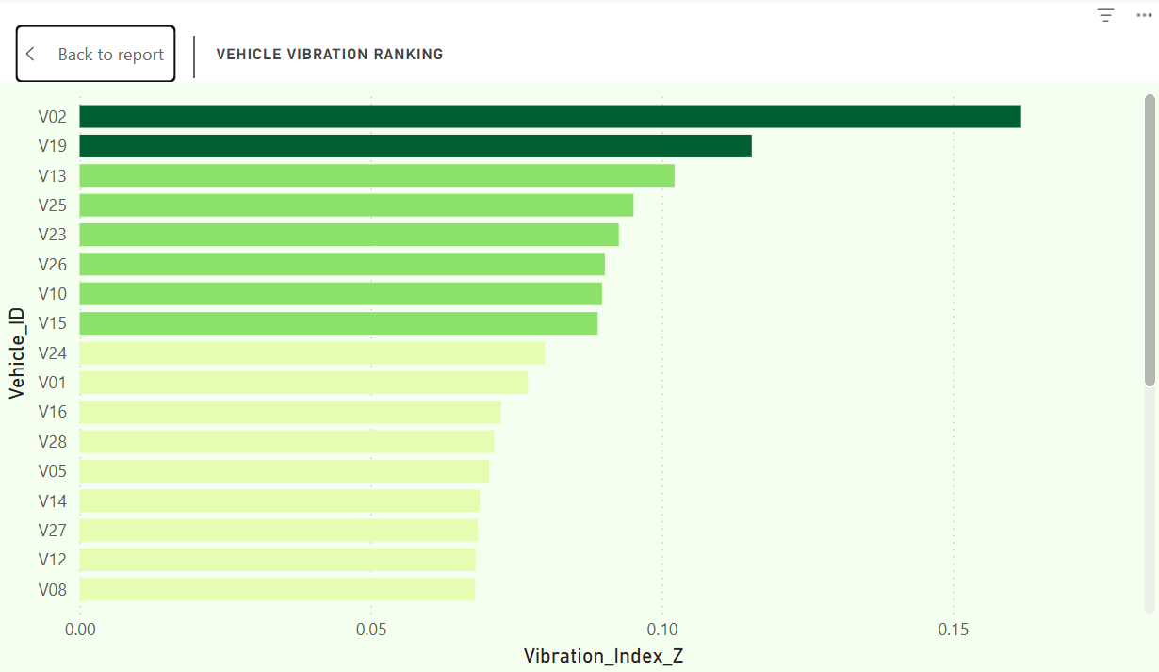

Visual 2 — Fleet Health Mix (Donut Chart)
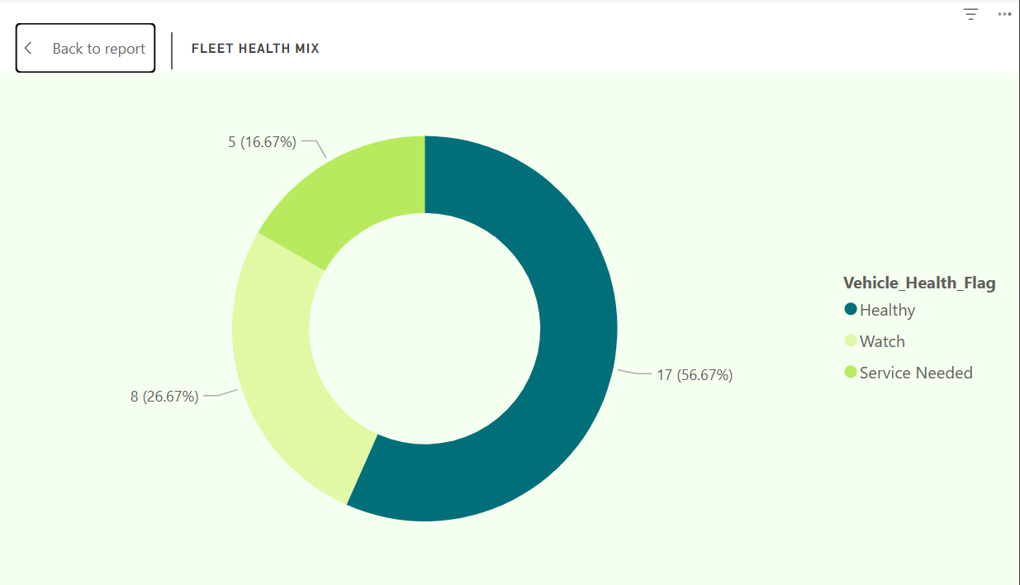

Visual 3 — Wear Correlation Scatter Plot
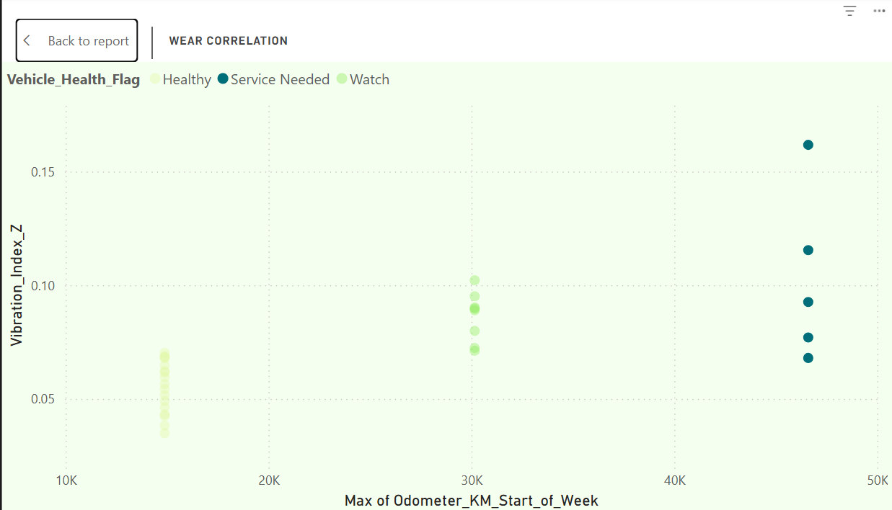

Visual 4 — Service Overdue (Column Chart with Threshold Line)
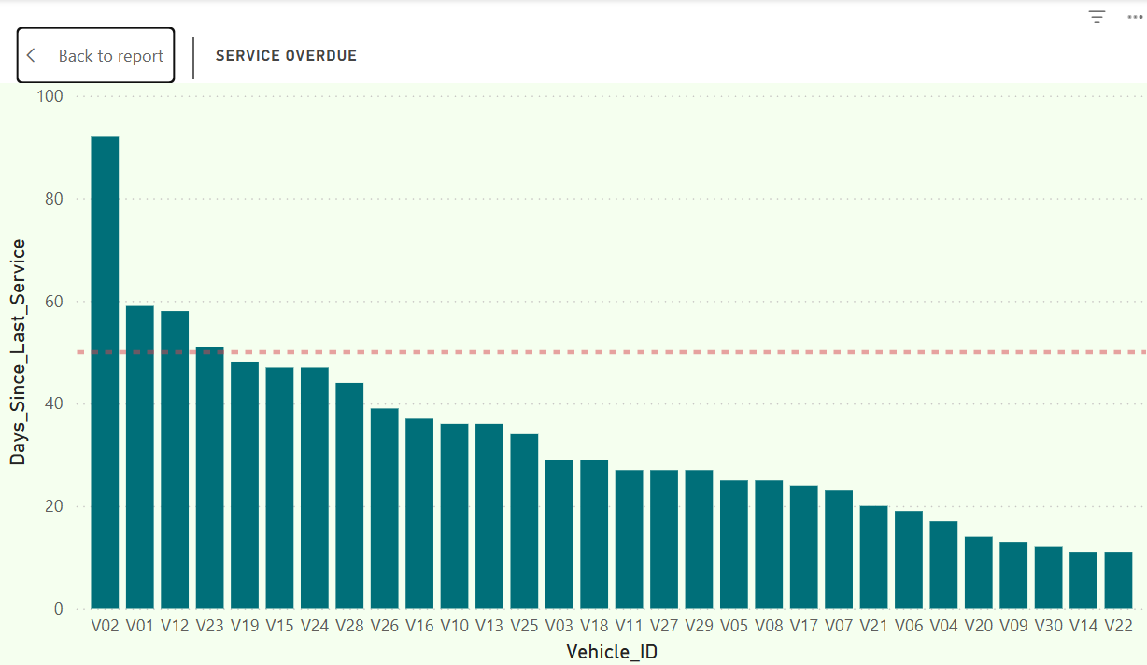

Slicers
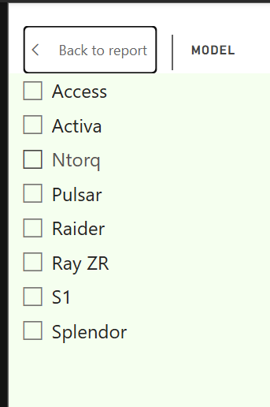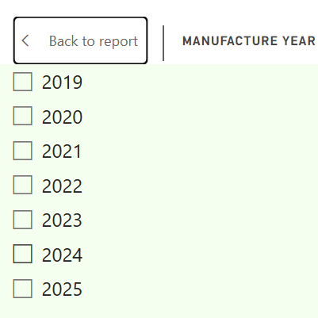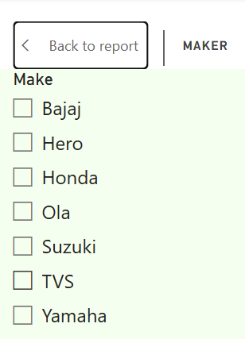

Daily degradation visual
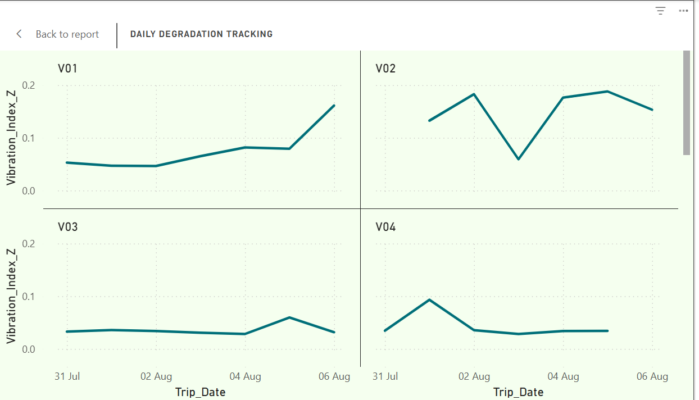

Maintenance Table
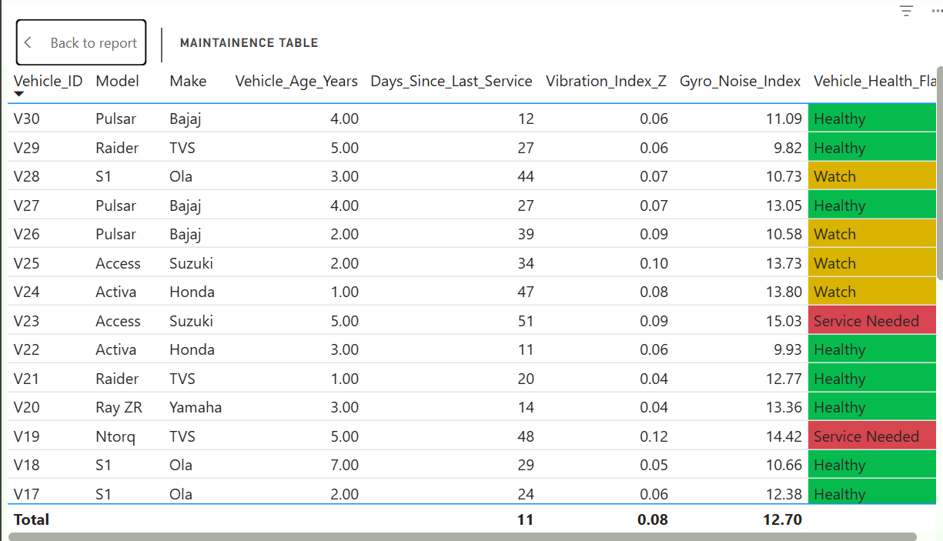

Dashboard
